**Laboratory work 9**

**Part-1 FreeCodeCamp ES6**

Send screenshots which show that you finished the ES6 and Basic Algorithm Scripting.

1.1 Do all 29 parts. <https://www.freecodecamp.org/learn/javascript-algorithms-and-data-structures/#es6>

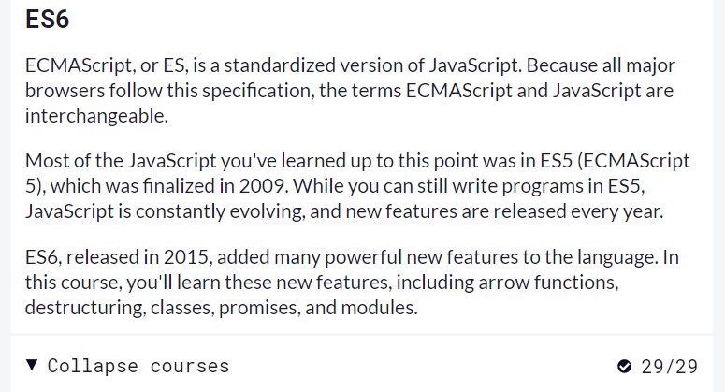

Do all 16 parts. <https://www.freecodecamp.org/learn/javascript-algorithms-and-data-structures/#basic-algorithm-scripting>

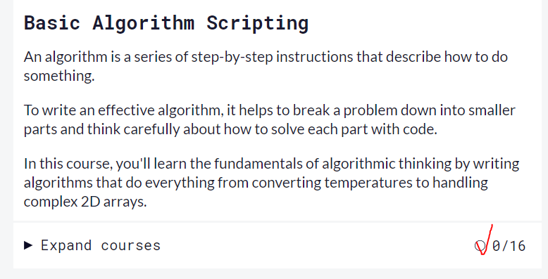

**Part-2 Vanilla JavaScript Projects.**

**Send your code in one ZIP file. (3 folders for each project, in each folder it’s index.html, style.css and app.js files)**

Watch video <https://www.youtube.com/watch?v=3PHXvlpOkf4&t=421s> until 1:11:30 (time) and see how following 3 projects are done. Repeat after the video. You’ll be asked to do a random project from this list during the DEFENSE.

1. [How to create a Color Flipper](https://www.freecodecamp.org/news/javascript-projects-for-beginners/#how-to-create-a-color-flipper)
2. [How to create a counter](https://www.freecodecamp.org/news/javascript-projects-for-beginners/#how-to-create-a-counter)
3. [How to create a review carousel](https://www.freecodecamp.org/news/javascript-projects-for-beginners/#how-to-create-a-review-carousel)